**OUTREACH SCHOOLS EXAMINATIONS BOARD**

**MID TERM I EXAMINATIONS 2023**

**TOP CLASS: (5 – 6 YEARS)**

**LEARNING AREA 5: LANGUAGE DEVELOPMENT II**

**Name: ……………………………………………………………………….**

**Class: ……………………………………… Date: ………………………..**

1. **Sound with actions.**

c f d h m g s p a

1. **Draw a picture for each sound.**

|  |  |  |  |  |  |
| --- | --- | --- | --- | --- | --- |
| b | m | d | a | g | j |
|  |  |  |  |  |  |

1. **Read the vowel words.**

mat cat egg bus pen

ill ox up cut in

1. **Match sound to picture.**

f



h

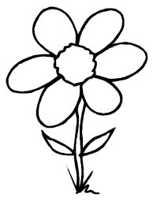

k

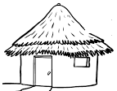

j

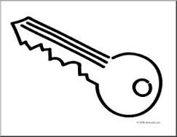

z

1. **Read and draw.**

axe _____________ cup __________

box _____________ dress __________

fish _____________ egg __________

1. **Join and form words.**

d-o-t = dot b-i-g = _________

b-o-x = _________ b-e-ll = ________

m-a-n = ________ s-a-m = _______

1. **Copy the same.**

**c c c c c c**

__________________________________________________________________________________________________________________________________________________________________________________________________________________

**cat cow car**

__________________________________________________________________________________________________________________________________________________________________________________________________________________

**c c c c c c**

__________________________________________________________________________________________________________________________________________________________________________________________________________________

**can candle cup**

__________________________________________________________________________________________________________________________________________________________________________________________________________________

**Cathy has a candle.**

__________________________________________________________________________________________________________________________________________________________________________________________________________________

**c c c c c c c c c c c**

__________________________________________________________________________________________________________________________________________________________________________________________________________________

***“Good Luck”***